TRD:
Section | Details
Project Title | Makani Finder – Real Estate Web Application
Developer | Ahad
Platform | ASP.NET Web Forms
Database | MS SQL Server
Frontend | HTML5, CSS3, JavaScript
Backend | ASP.NET (VB/C#)
Hosting | IIS or localhost demo deployment
Target Areas | Salalah and Sohar
Property Types | Villas and Flats (2 properties per type, per area)
Pages Required | Home, Area, Property Type, Property Listings, Property Info, Purchase, Queries
Features | Navigation, property browsing, dynamic content, forms, client registration, search, EMI calc.
Accessibility | XHTML compliance, keyboard/mouse support, print-friendly pages
Security | Unique client email, CVV validation, EMI input constraints, safe database interaction
Browser Support | Chrome, Firefox, Edge, Safari
Page Design | Controlled via Master Pages and Themes
User Experience | Clear layout, breadcrumb navigation, visual cues, logo-based links, consistent styling
Print Compatibility | All pages must support print view with only relevant content shown
Data Validation | All forms must validate required fields and user inputs
Purchase Logic | Credit card and cash, with EMI options and conditional interest rates
Reporting | Last update date, contact info, location map, footer on all pages

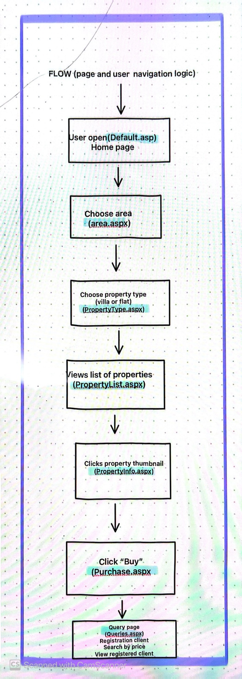
Flow:

Flow:
Tables:
1. TABLE: Clients
4. TABLE: Properties
- PropertyID (PK)
- TypeID (FK)
- Address
- AskingPrice
- Thumbnail
- Description
- Image
- Features
- Rooms
- Location
- Solicitor
- ViewingDetails
5. TABLE: Purchases
- PurchaseID (PK)
- PropertyID (FK)
- ClientID (FK)
- PaymentType (Cash/CreditCard)
- CardNumber
- CVV
- PaymentMode (Single/Installments)
- Months
- FinalPrice
- PurchaseDate

- ClientID (PK)
- FullName
- Email (Unique)
- Town
- Phone
- Mobile
2. TABLE: Areas
- AreaID (PK)
- AreaName
- Description
- Facilities
- Education
- Medical

3. TABLE: PropertyTypes
- TypeID (PK)
- AreaID (FK)
- TypeName (Villa/Flat)

